HERITAGE TREASURE:
AN IN-DEPTH ANALYSIS OF UNSESCO WORLD HERITAGE SITES IN TABLEAU
Submitted in partial fulfilment of the requirments for the degree of
BACHELOR OF BUSINESS
ADMINISTRATION
By
P. MOHAN BALAJI
(24B91M0035)


SAGI RAMAKRISHNAM RAJU ENGINEERING COLLEGE, BHIMAVARAM
2026-2027

DASHBOARD DESIGN

1.Introduction:
After creating individual visualizations, all worksheets were combined into a single interactive dashboard. The dashboard provides a comprehensive view of UNESCO World Heritage Sites and enables users to analyze data efficiently through interactive filters.
The dashboard was designed using Tableau Public with a clean layout, proper color combinations, legends, and titles to improve readability.
2. Dashboard Components
The dashboard consists of the following visualizations:
- Visualization
- Purpose
- Treemap
- Country-wise Heritage Sites
- Pie Chart
- Heritage Sites in Danger
- Line Chart
- Year-wise Inscription Trend
- Bar Chart
- Top Countries
- Map
- Geographic Distribution
- Stacked Bar Chart
- Heritage Categories
3. Dashboard Layout:
The dashboard is divided into different sections:
- Header
- Project Title
- UNESCO Logo (Optional)
- Left Panel
- Filters
- Country
- Region
- Category
- Danger Status
- Center Panel
- Treemap
- Pie Chart
- Bottom Panel
- Line Chart
- Bar Chart
- Map
- Footer
- Project Name
- Student Name
- Tableau Public Link
4. Dashboard Features:
The dashboard provides several interactive features:
- Interactive Filters
- Dynamic Charts
- Responsive Layout
- Drill-down Analysis
- Hover Tooltips
- Automatic Updates
5. Filters Used:
The following filters were added:
- Country Filter
- Allows users to analyze heritage sites of a selected country.
Example: India → Displays only Indian Heritage Sites.
- Region Filter
- Displays heritage sites belonging to a selected UNESCO region.
Example: Asia-Pacific
- Category Filter
- Allows users to select
- Cultural
- Natural
- Mixed
- Danger Status Filter
- Displays
- In Danger
- Not In Danger

6.Tableau Dashboard URL:
https://public.tableau.com/views/UNESCOProject_01/Project_01?:language=en-US&publish=yes&:sid=&:redirect=auth&:display_count=n&:origin=viz_share_link

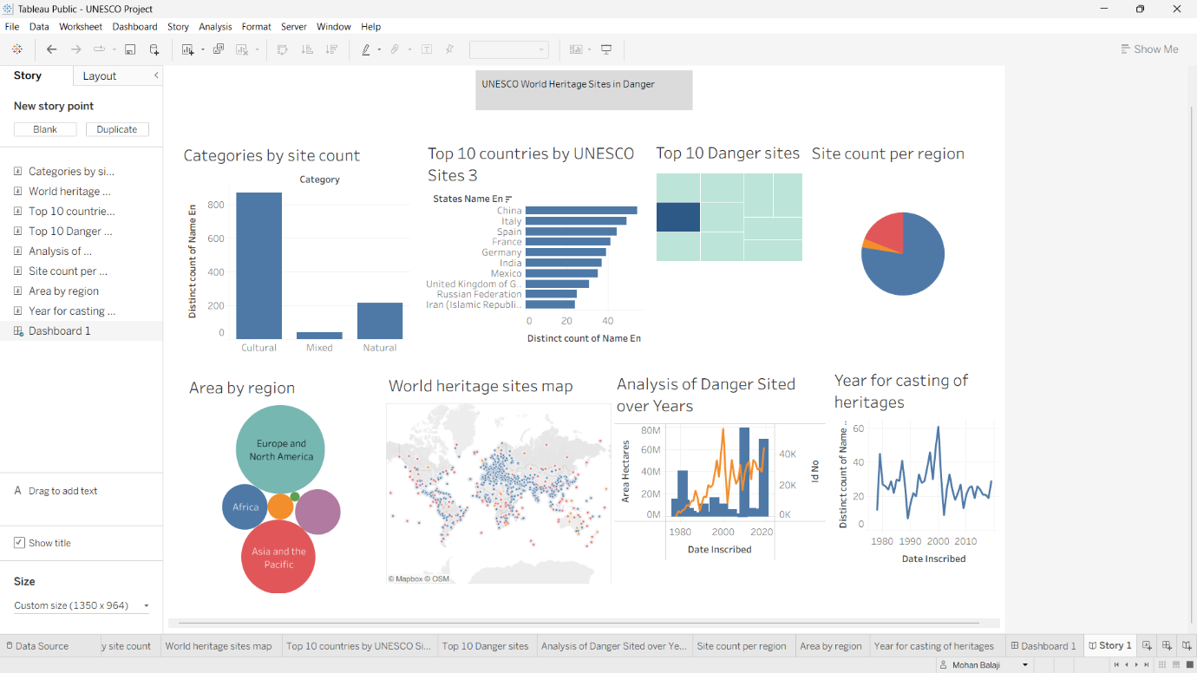
Fig.1

STORY CREATION

1.Introduction:
Tableau Story presents the project in a logical sequence.
The story consists of five scenes.
Story Point 1
Provides an overview of UNESCO World Heritage Sites and explains the objective of the project.
Story Point 2
Country-wise Analysis
Shows coun
tries with the highest number of heritage sites using a Treemap.
Observation: Countries such as Italy, China, and Spain contain a high concentration of heritage sites.
Story Point 3
Heritage Sites in Danger
Displays endangered heritage sites using a Pie Chart.
Observation: Only a small percentage of heritage sites are officially classified as "In Danger."
Story Point 4
Regional Trends
Illustrates yearly UNESCO inscriptions using a Line Chart.
Observation: The number of inscriptions has generally increased over the years.
2. Story Structure:
Tableau Storytelling is a powerful feature that allows the presentation of data findings in a sequential, narrative format. Unlike a dashboard which displays all information simultaneously, the Story feature guides the audience through the project’s objectives, key data points, and final conclusions, creating a cohesive and logical flow.

3.Tableau Story URL:
https://public.tableau.com/shared/PM8YBKJ2P?:display_count=n&:origin=viz_share_link

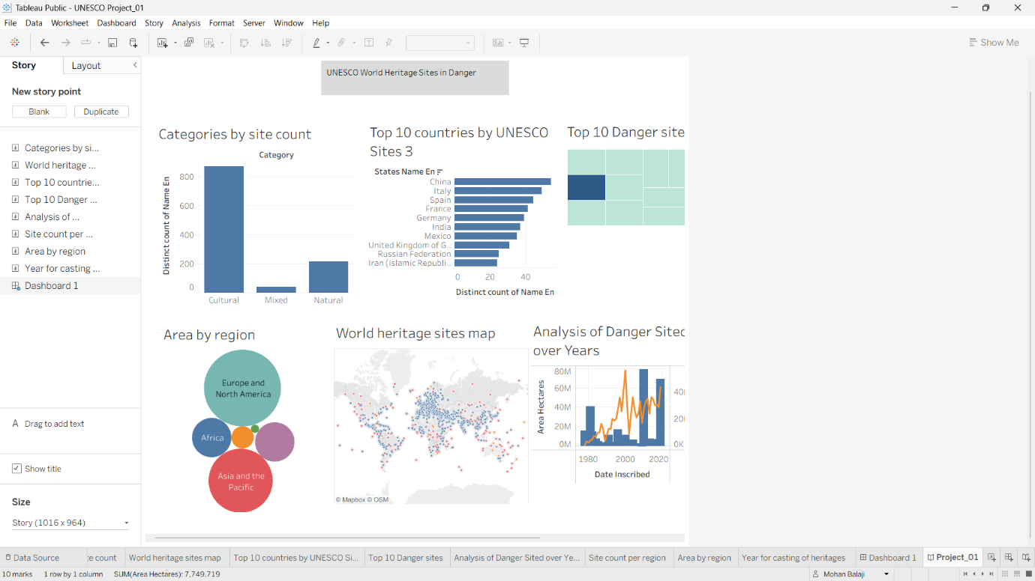
Fig.2

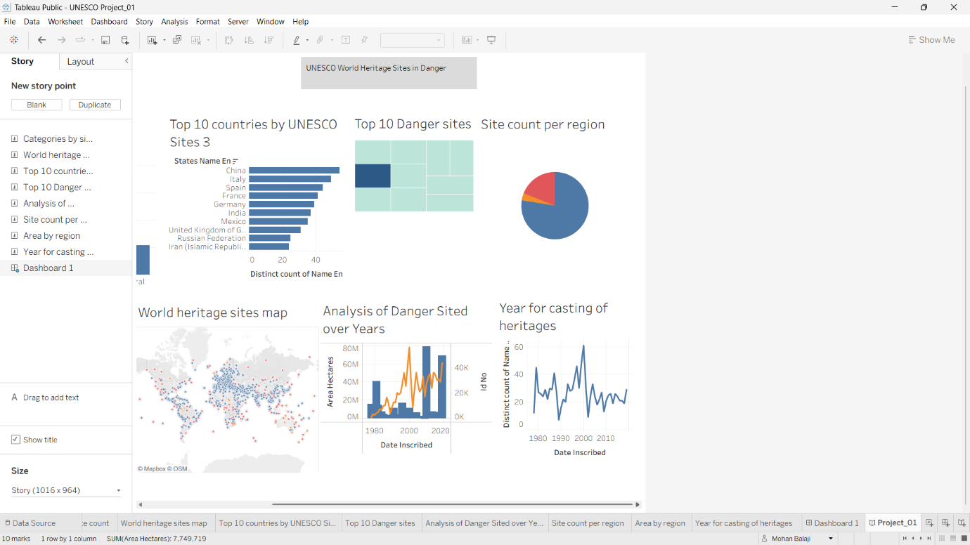
Fig.3

4.Conclusion:
Summarizes the findings and highlights the importance of preserving cultural and natural heritage.
Publishing the Dashboard and story:
The completed Tableau workbook was published to Tableau Public.
Steps:
Click File → Save to Tableau Public
- Sign in to Tableau Public.
- Enter a workbook name.
- Publish the dashboard and story.
- Copy the public URL.
- Publishing makes the dashboard accessible through any web browser.

